**Lab Report: 01**

**Title: Scan conversion**

*Course title: Computer Graphics Laboratory*

*Course code: CSE-304*

*3rd Year 1st Semester Examination 2022*

**Date of Submission**: 28/05/2023



**Submitted to-**

*Dr. Mohammad Shorif Uddin*

*Professor*

*Department of Computer Science and Engineering*

*Jahangirnagar University*

*&*

*Dr. Morium Akter*

*Associate Professor*

*Department of Computer Science and Engineering*

*Jahangirnagar University*

*Savar, Dhaka-1342*

| Class Roll | Registration Number | Name |
| --- | --- | --- |
| 346 | 20200650716 | Solaimi Hamid |

**Experiment Number: 01**

**Experiment Name: Scan conversion of a point.**

**Source code:**

#include<bits/stdc++.h>

#include<graphics.h>

#include<dos.h>

using namespace std;

int main()

{

int gd=DETECT;

int gm,p;

int x1,y1;

initgraph(&gd,&gm,"");

cout<< "Enter the co-ordinates: ";

cin>>x1>>y1;

putpixel(x1,y1,RED);

getch();

closegraph();

}

**Output:**

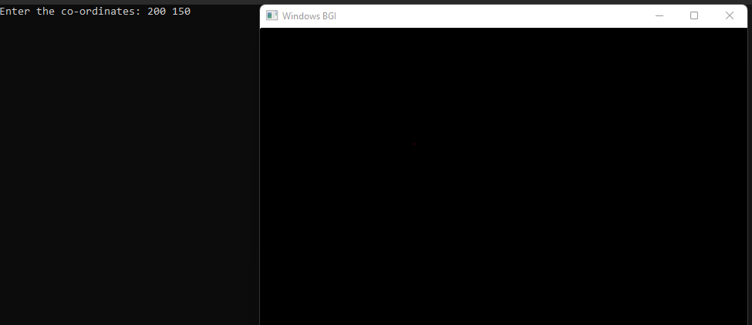

**Experiment Number: 02**

**Experiment Name: Scan conversion of a straight line using DDA Algorithm.**

**Source code:**

#include<bits/stdc++.h>

#include<graphics.h>

#include<dos.h>

#include<math.h>

using namespace std;

int main()

{

int gd=DETECT,gm;

int x1,y1,x2,y2,dx,dy,steps,xinc,yinc;

initgraph(&gd,&gm,"");

cout<<"Enter starting coordinates: ";

cin>>x1>>y1;

cout<<"Enter ending coordinates: ";

cin>>x2>>y2;

dx= x2-x1;

dy= y2-y1;

if(abs(dx)>abs(dy))

steps=(dx);

else

steps=(dy);

xincr=dx/steps;

yincr=dy/steps;

for(i=0;i<steps;i++)

{

putpixel(x1,y1,3);

x1=x1+xincr;

y1=y1+yincr; }

getch();

closegraph(); }

**Output:**

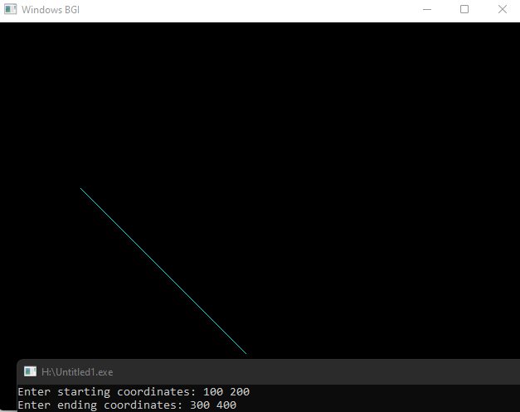

**Experiment Number: 03**

**Experiment Name: Scan conversion of a straight line using Bresenham Algorithm.**

**Source code:**

#include<bits/stdc++.h>

#include<graphics.h>

#include<dos.h>

using namespace std;

int main()

{

int gd=DETECT;

int gm,p;

int x1,y1,x2,y2,dx,dy,steps;

initgraph(&gd,&gm,"");

cout<< "Enter starting co-ordinates: ";

cin>>x1>>y1;

cout<< "Enter ending co-ordinates: ";

cin>>x2>>y2;

dx=x2-x1;

dy=y2-y1;

p=2*dy-dx;

putpixel(x1,y1,3);

for(int i=0;i<dx;i++)

{

if(p<0)

{

x1++;

p=p+2*dy;

}

else

{

x1++;

y1++;

p=p+2*dy-2*dx; }

putpixel(x1,y1,3);

delay(50); }

getch();

closegraph(); }

**Output:**

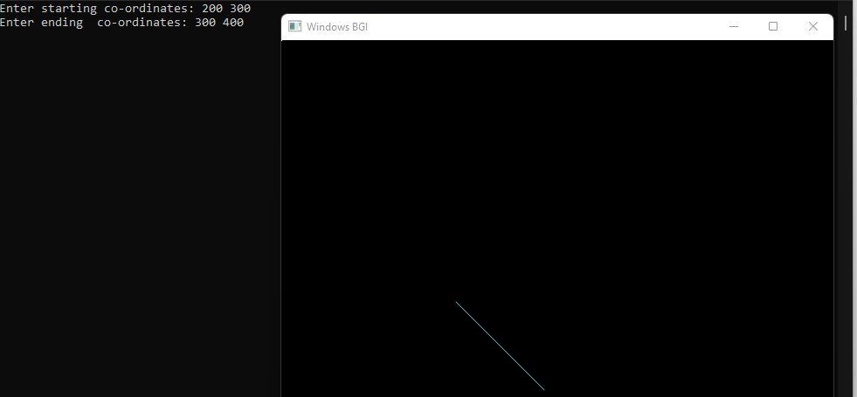

**Experiment Number: 04**

**Experiment Name: Scan conversion of a circle using Bresenham Algorithm.**

**Source code:**

#include <iostream>

#include <graphics.h>

void drawCircle(int xc, int yc, int radius)

{

int x = 0;

int y = radius;

int d = 3 - 2 * radius;

while (x <= y)

{

putpixel(xc + x, yc + y, GREEN);

putpixel(xc - x, yc + y, GREEN);

putpixel(xc + x, yc - y, GREEN);

putpixel(xc - x, yc - y, GREEN);

putpixel(xc + y, yc + x, GREEN);

putpixel(xc - y, yc + x, GREEN);

putpixel(xc + y, yc - x, GREEN);

putpixel(xc - y, yc - x, GREEN);

if (d < 0)

d += 4 * x + 6;

else

{

d += 4 * (x - y) + 10;

y--; }

x++; }}

int main()

{

int gd = DETECT, gm;

initgraph(&gd, &gm, "hello");

int xc = 200, yc = 200;

int radius = 200;

drawCircle(xc, yc, radius);

getch();

closegraph();

return 0;

}

**Output:**

